**Experiment 08: Ratio control**

**Name: Shaunak Deshpande**

**Div.: TY-IC-C**

**Roll. No.: 39**

**GR no.: 11911180**

**Batch.: 2**

**Class : TY B.Tech Instrumentation & Control**

**Course Name : Building & Process Automation**

**Title: Ratio Control**

This exercise is based on solids concentration control through the manipulation of the ratio between a main flow and a blend flow. The percent solids concentration exiting the blender is measured on-line and is the input to a concentration control. Changes in the inlet concentration of the main flow are a disturbance to the process. The process is shown below.

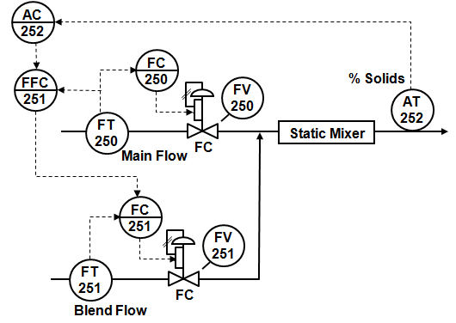

**Steps:**

* Step 1. In the ratio control workspace, change the mode of the Ratio block to Auto.
* Step 2. Change the Ratio SP (setpoint) over the following range: 0.3, 0.5, and 0.8. Observe the change in the blend flow and the process outlet concentration. Then set the Ratio SP to 0.5 and wait for the concentration to settle to a steady value.
* Step 3. Make a step change in the FEED and observe the way the ratio changes the dependent loop. Did the concentration change?
* Step 4. Change the ratio block to cascade mode. Change the setpoint of the analytical loop to 40% and observe the impact on the ratio setpoint. Does the measured concentration reach setpoint?

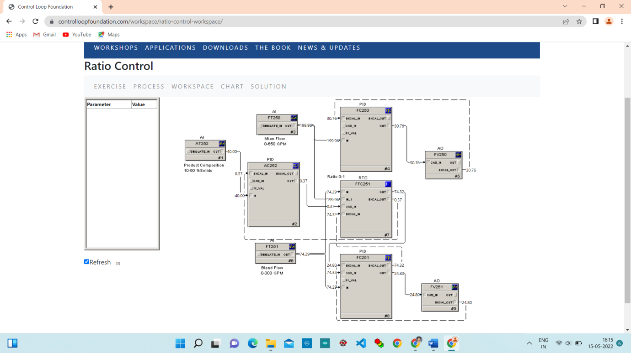

**Step 1**. In the ratio control workspace, change the mode of the Ratio block to Auto.

Change the mode from CASCADE to AUTO.

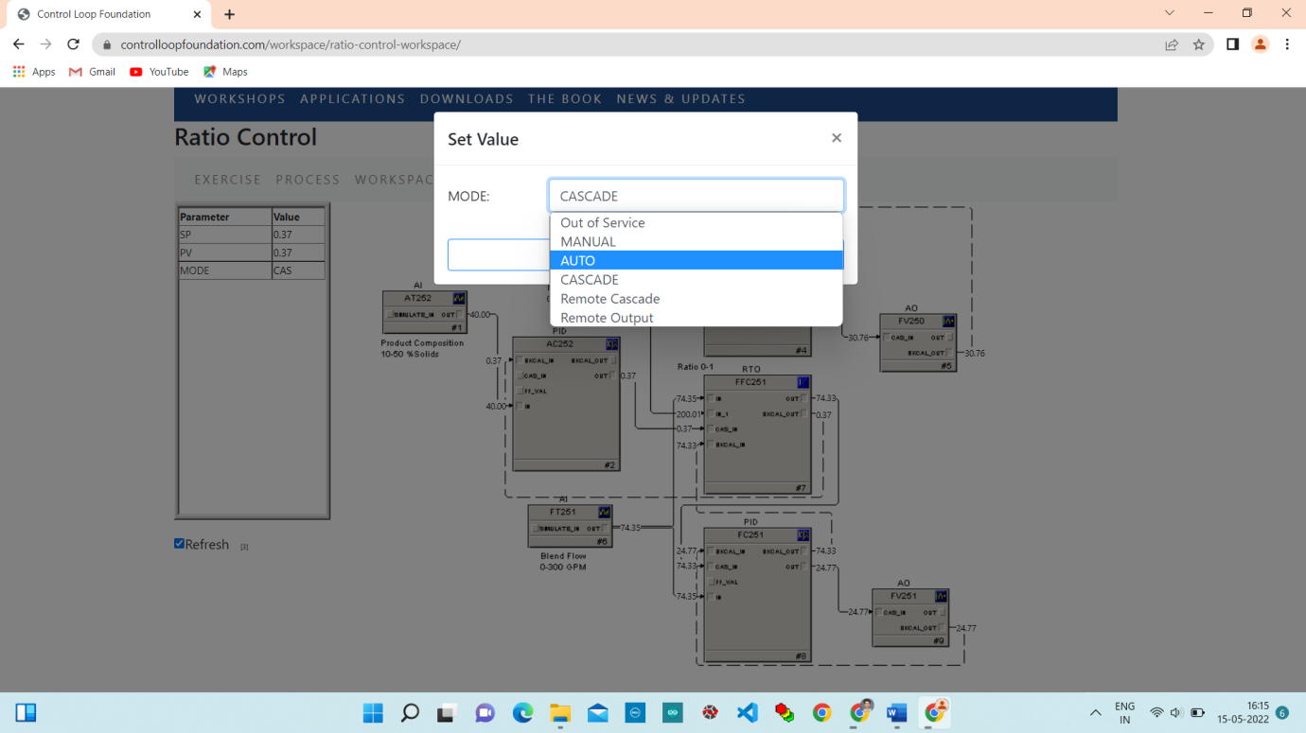

**Step 2.** Change the Ratio SP (setpoint) over the following range: 0.3, 0.5, and 0.8. Observe the change in the blend flow and the process outlet concentration. Then set the Ratio SP to 0.5 and wait for the concentration to settle to a steady value.

Change Setpoint from 0.37 to 0.3.

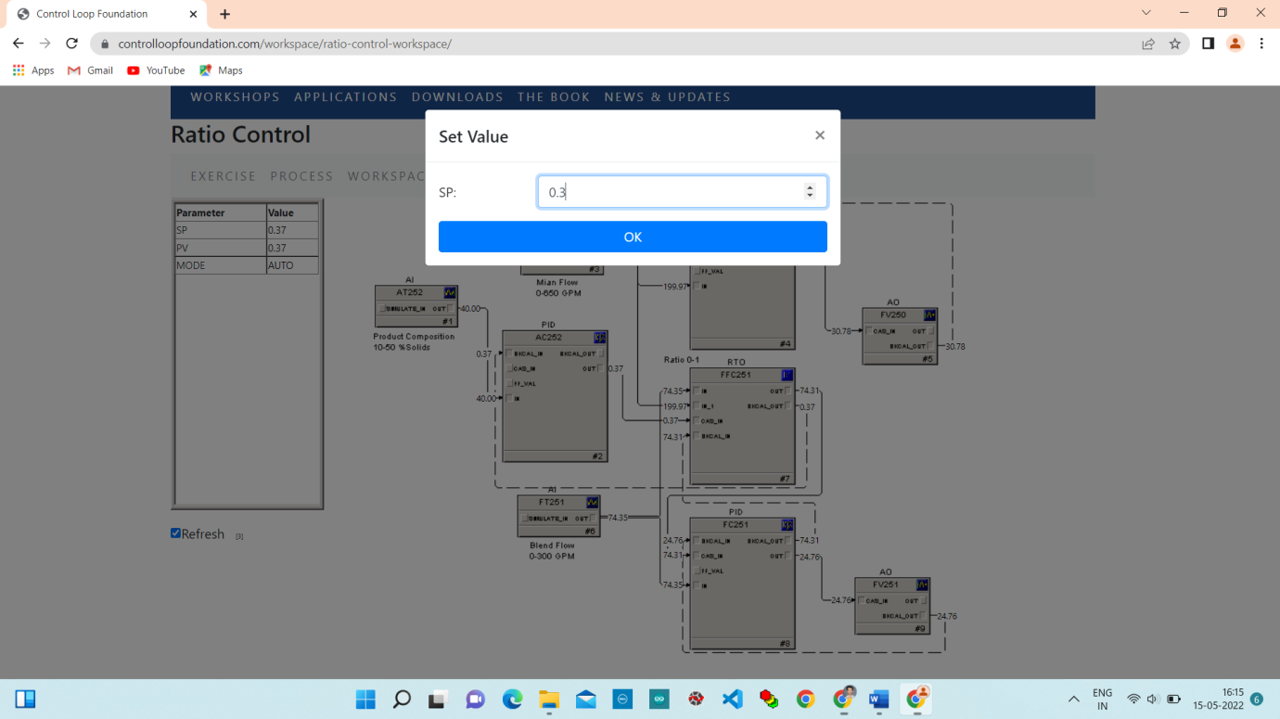

Change Setpoint from 0.3 to 0.5.

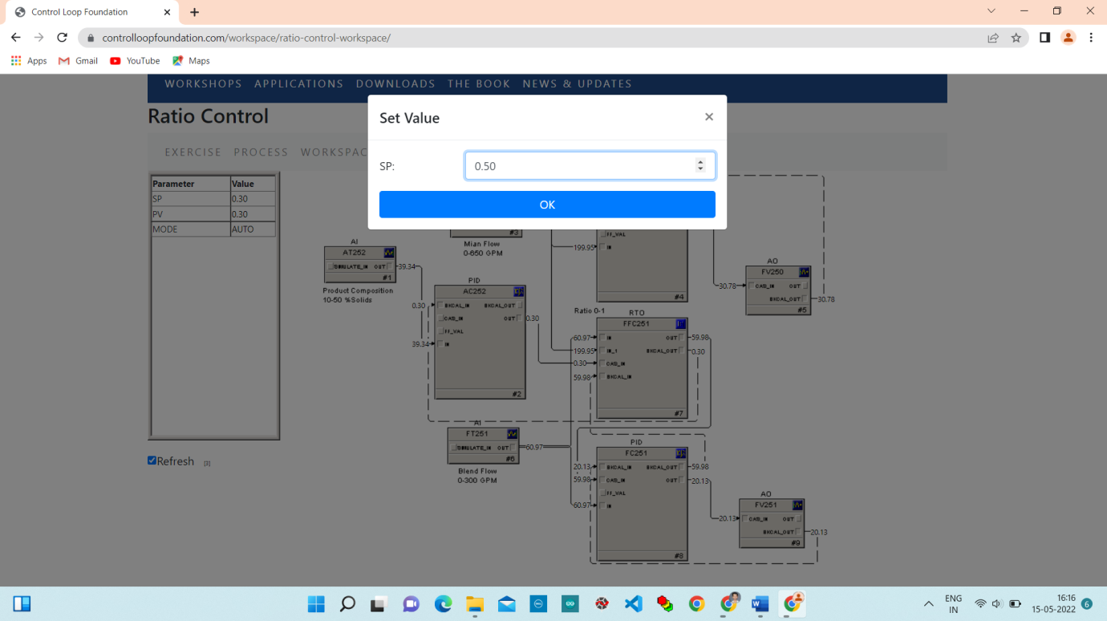

Change Setpoint from 0.5 to 0.8.

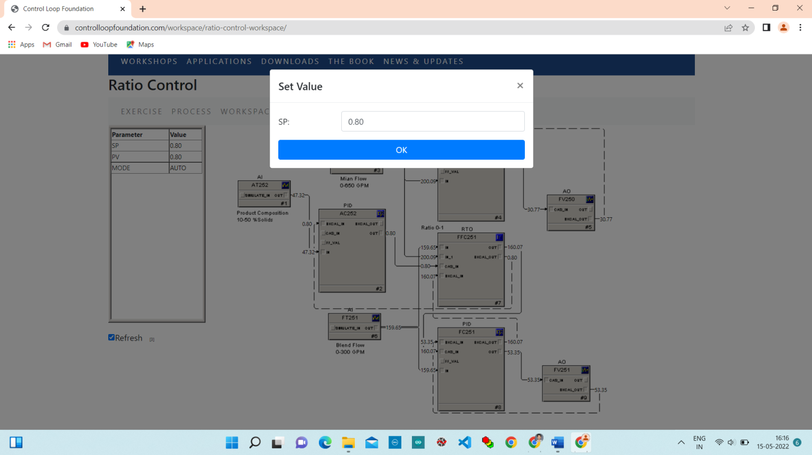

Change Setpoint from 0.8 to 0.5.

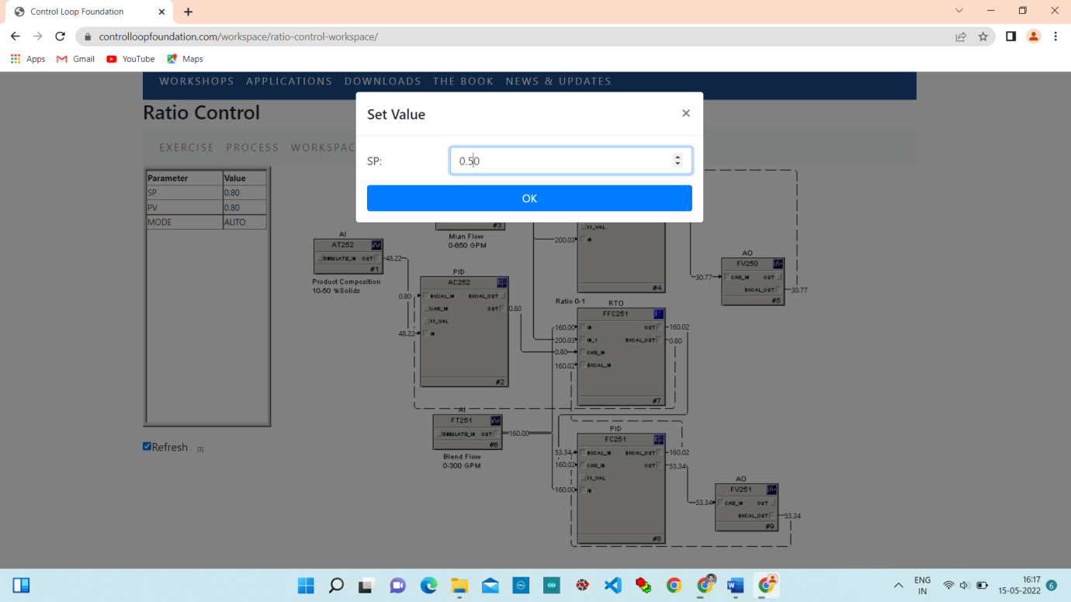

**Chart:**

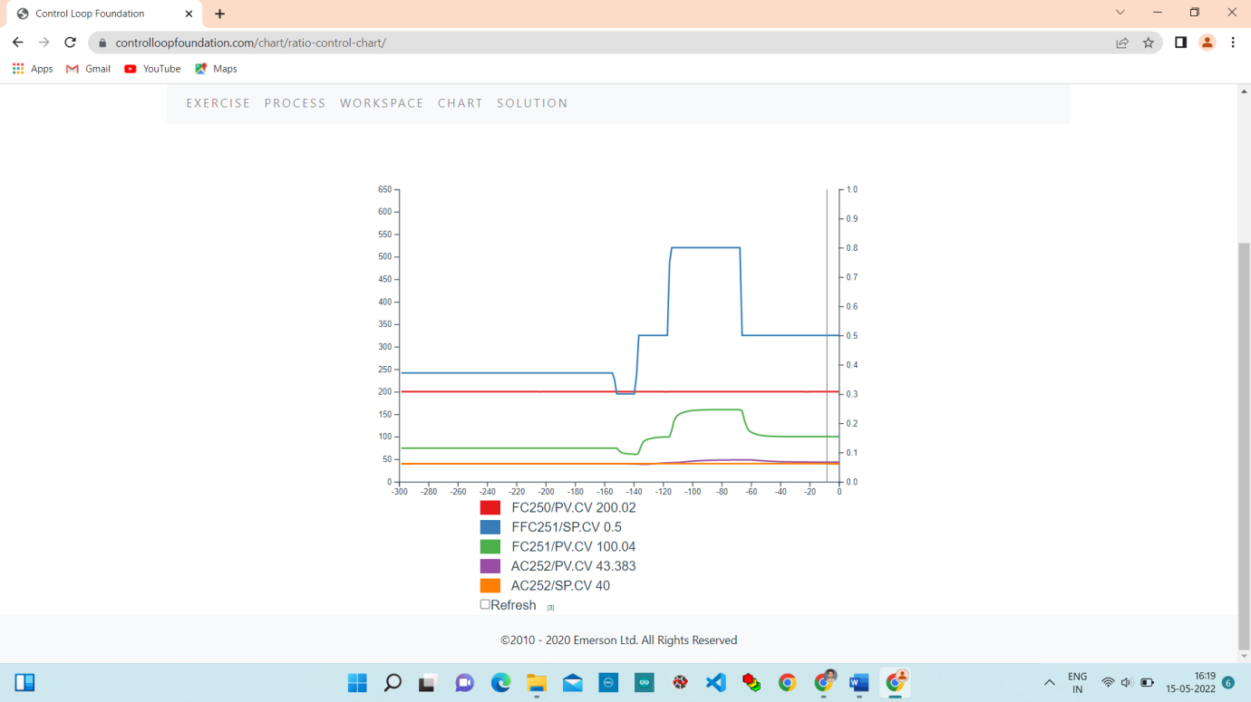

**Step 3**. Make a step change in the FEED and observe the way the ratio changes the dependent loop. Did the concentration change?

Change setpoint of PID controller from 200 to 250.

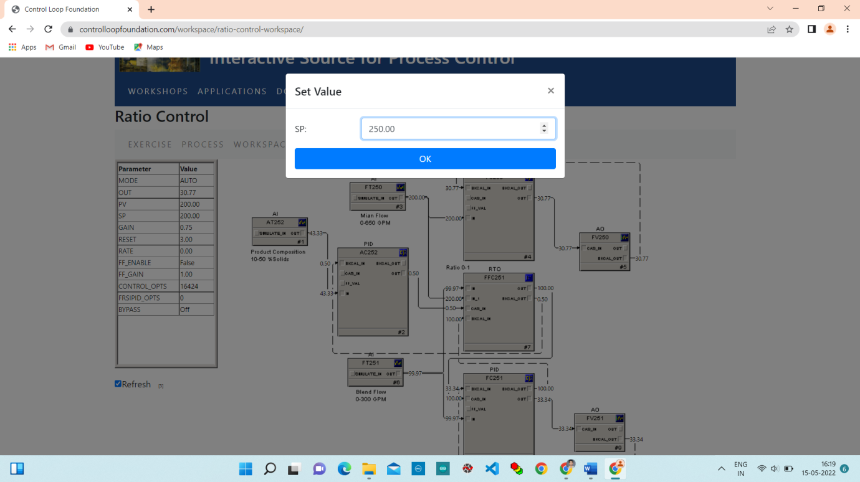

**Chart:**

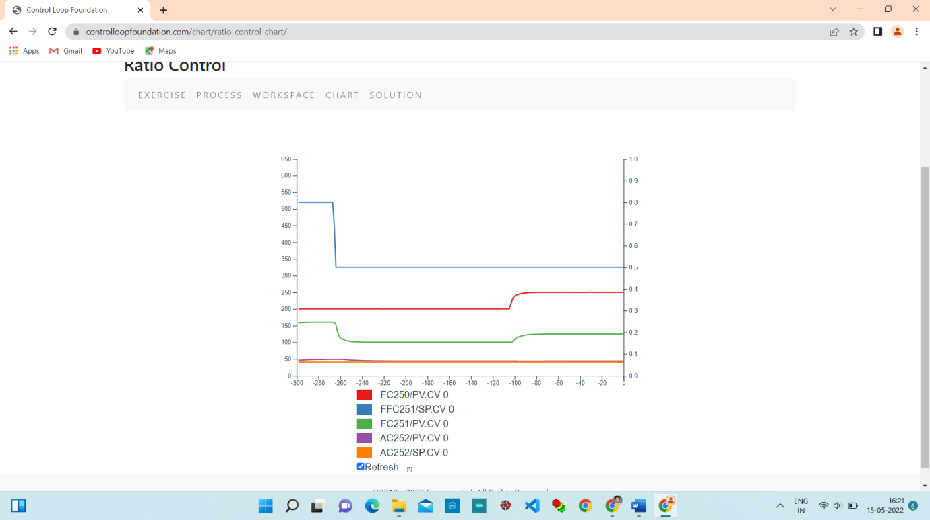

**Step 4**. Change the ratio block to cascade mode. Change the setpoint of the analytical loop to 40% and observe the impact on the ratio setpoint. Does the measured concentration reach setpoint?

Change Mode from AUTO to CASCADE.

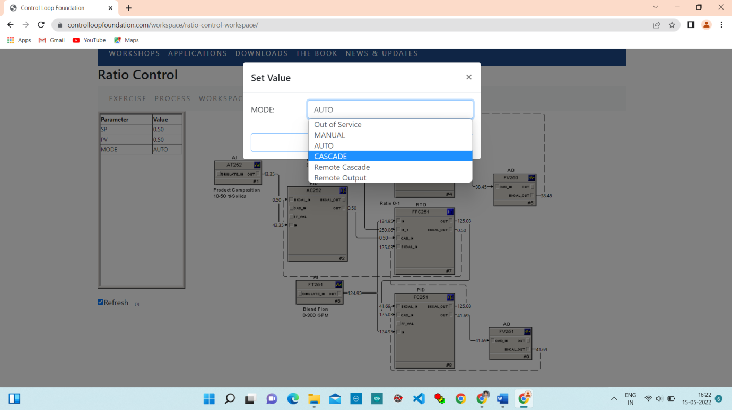

**Chart:**

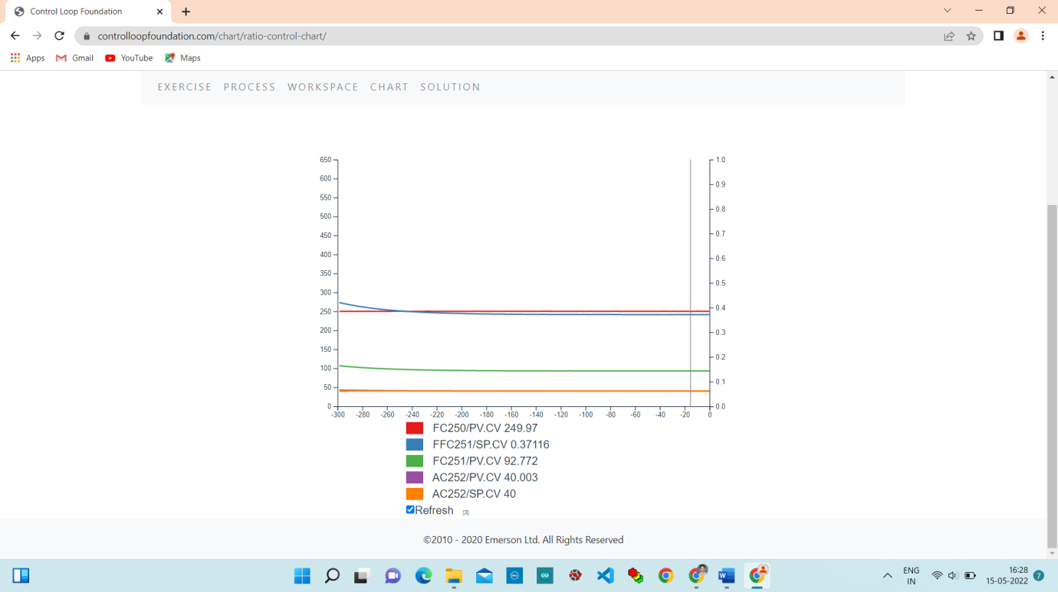

**Conclusion:**

In this lab we studied operation of ratio control and also learned about how process stream concentration is maintained at setpoint through the regulation of the blended streams ratio setpoint.